ENTRY METHOD

ENTRIES WILL OPEN ON Wednesday, April 1, 2026, 12:01am EST. All entries received before this date will be returned.

ENTRIES CLOSE ON Saturday, May 2nd, 2026, 6pm EST after which time entries cannot be accepted,

cancelled, altered, or substituted.

DAY OF EVENT ENTRIES: Day of event entries will be permitted at this Fetch testing.

PREMIUM LIST
FETCH INTO SUMMER EVENT

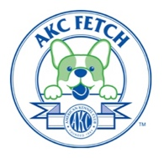
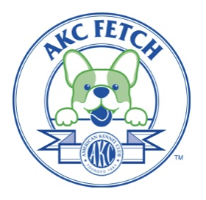

Hosted by Judge Brandy Dunaway

At the Scent Sports Dog Training Center


Levels to be tested: Novice, Intermediate, Advanced, & Retriever
Drop-in testing also available for:
Canine Good Citizen (CGC)
Canine Good Citizen Advanced (CGCA)
AKC Tricks (bring your own props)
Cash payment on day of the event for ALL testing including fetch
-DAY OF EVENT ENTRIES ACCEPTED-
May 2, 2026 Event # 2026790050 and Event # 2026790051

____________________________________________________________________

Location of the event:
Scent Sports Dog Training Center
1327 Drakeford Rd, Cassatt, SC 29032
(Mail entries to the trial secretary, not this address)

ENTRY LIMITS

125 entries per Fetch event

To be held outdoors

Check-in Testing Hours:

8 am – 9:15 am 9:30 am to 4:30 pm

CERTIFICATION


Permission is granted by the American Kennel Club for the holding of this event under American Kennel Club rules and regulations.

Gina DiNardo, Secretary

OFFICERS OF THE SCENT SPORTS DOG TRAINING CENTER

President ………………………………………………………………….…..Chris Puls
Vice President ………………………………………………………………...Brandy Dunaway
Secretary…………………………………………………………………….…Angel Danyel

Treasurer………………………………………………………………………Lindsay Waddell

 | TRIAL CHAIRPERSON |  | TRIAL SECRETARY
Chris Puls  1327 Drakeford Rd, Cassatt, SC 29032  DogScouts@hotmail.com  513-313-5113 |  | Angel Danyel  105 Edward View Rd Columbia, SC 29203  clubsecretary.angel@gmail.com  803-719-0192

EVENT COMMITTEE

Chris Puls, Angel Danyel, Lindsay Waddell, Beth Lewis, Wanda Austin

JUDGES AND ASSIGNMENTS

Brandy Dunaway,  #114795 |  | Justine Borghello,  # 112812
Columbia, SC |  | York, SC
May 2, 2026 Trial #1 |  | May 2, 2026 Trial #2
Judging all levels of trial 1 |  | Judging all levels of trial 2

VETERINARIAN

Nearest vet open on Saturdays: CVETS 1321 Oakcrest Dr, Columbia, SC 29223
(803) 995-8913 (35 miles away)

EMERGENCY SERVICES

Fire/ Ambulance/Police- Kershaw County Sherriff

911

Nearest Hospital:
MUSC Health Kershaw Medical Ctr,
1315 Roberts St, Camden, SC 29020 (7 miles away)

TEST LEVELS OFFERED & Dates

Sat May 2  Trial 1 |  | Sat May 2  Trial 2
Novice | Followed by> | Novice
Intermediate | Followed by> | Intermediate
Advanced | Followed by> | Advanced
Retriever | Followed by> | Retriever
Testing begins at 9:30 a.m. for
Novice Trial 1, followed by Nov T2, followed by
Int. T1 then Int. T2, then Adv T1, then Adv T2, then Retriever T1, then Retriever T2

Move-Ups to the next higher level WILL be offered. Please let the Trial Secretary know as soon as you finish your title run that you want to move up. Must be done before trail 2 starts.

DOG ELIGIBLE TO ENTER

This trial is open to all dogs SIX (6) months of age or older that are registered with the American Kennel Club or that have AKC Limited Registration, Purebred Alternative Listing/Indefinite Listing Privileges (PAL/ILP), an AKC Canine Partners listing number or approved Foundation Stock Service (FSS) breeds are eligible to participate. Dogs with a Purebred Alternative Listing/Indefinite Listing Privileges (PAL/ILP) or an AKC Canine Partners listing number must be spayed or neutered in order to compete.

Condition of the Dog. Dogs with physical challenges (including amputees) are eligible to participate provided that, in the opinion of the judge, they display no signs of physical discomfort and can safely complete the Fetch test. Dogs with bandages, sutures, or visible wounds are not eligible. Deaf dogs are allowed to enter so long as the handler is in control of the dog at all times, the dog can complete the requirements of the test, and the dog does not appear to be under undue stress in the opinion of the judge.

--------------------------------------------

ENTRY OPTIONS

- Visit https://scentsportsdtc.com/fetch-into-summer-event/ to do an online entry.
- You may print, fill out, and mail the entry form (pg. 7-8 of this premium) to the trial secretary (address below).
- Bring the completed form with you and be sure to arrive and check-in between 8 and 8:30 am.

Payment for ALL tests will be cash upon arrival at the trial site.
Day of event entries allowed if test is not full.
If printing/sending your entry form, please mail it to the trial secretary:

Angel Danyel- Fetch Test
105 Edward View Rd
Columbia, SC 29203

No entries will be accepted by phone, email, or fax. Day of event entry may be hand delivered to the check in table by 8:30. Inquiries may be directed to Angel Danyel at clubsecretary.angel@gmail.com. No entry shall be made, and no entry shall be accepted, which specifies any conditions as to its acceptance.

Illegible entries will not be processed and will be returned to the exhibitor.

-----------------------------------
WAIT LIST INFORMATION

There will not be a waitlist to fill openings created by ‘no shows’ on the day of the trial. All entries must be received by the Trial Secretary prior to the start of the first trial on May 2nd, 2026. No entries may be withdrawn with a refund after the start of the event.
---------------------------
SIGN-IN and CRATING Areas

There will be a secretary table for check-ins and information.
Dogs will need to be crated in or at your vehicle and should be out of view from the Fetch test area, or far enough away as to not cause a distraction to the dog being tested.

ADDITIONAL SITE INFORMATION

Exhibitors are responsible for cleaning up after their dog(s). Any exhibitor failing to do so may be excused without benefit of refund if the Event Committee deems the exhibitor to be in violation of this requirement. Cleaning supplies and disposal sites will be available at various locations around the show grounds.
RIBBONS, AWARDS, AND PRIZES

Qualifying Score……………………………………………….…………...…..…...Dark Green
NOTICE TO EXHIBITORS

SAFETY, BEHAVIOR and LIABILITY

The safety of the dog is our primary concern. By entering this trial, exhibitors acknowledge that they are familiar with the rules and regulations of this sport, and that their dogs are familiar with and able to perform all searches safely. It is expressly understood that exhibitors alone are responsible for the behavior of their dogs and/or children. Any exhibitor whose dogs and/or children create an unnecessary disturbance or repeatedly engage in unsafe or disruptive behavior may, at the discretion of the trial committee, be asked to leave the show site. In such case, no refund of any fees paid will be made. The American Kennel Club, Brandy Dunaway, and Chris Puls, owner of Scent Sports Dog Training center and their agents, employees, etc., will assume no responsibilities for any loss, damage or injury sustained by exhibitors or handlers, or to any of their dogs or property and further assumes no responsibility for injury to children. The trial committee reserves the right to decline entries for cause and may remove any dog on account of aggression. No one shall have any recourse or claim against the American Kennel Club, host, or trial location owner or any official thereof.
Collars, Leashes, and Harnesses. Dogs must wear a collar. Dogs may wear slip collars, buckle collars, and Martingales in the AKC Fetch test. They may not wear prong collars, e-collars, head collars, muzzles, or body harnesses. Leashes should be 4 ft. to 6 ft. long and should be made of fabric, leather, or biothane.

REFUNDS

As per the AKC Fetch Judges Guide, when a Fetch test is cancelled, the club/organizer will contact any preregistered entrants. The club/organizer will communicate the change to any potential entrants by the method in which they originally advertised to those potential entrants.
If the club/organizer cancels the Fetch test, preregistered entrants will be given a refund for their entry fees. The cancellation should be reported to fetchinfo@akc.org
No entry fee will be refunded in the event a dog is absent, disqualified, excused, or barred from competition by the action of the Trial Committee. Dogs pulled after closing because of injury or other medical condition are not eligible for a refund.

Bitches in season will be refunded the full entry fee. Notification in writing must be given to the trial secretary no later than one half hour prior to the start of the first class of the day of the trial.

RINGSIDE

Judges are not required to wait for dogs. The Handler of each dog is solely responsible for having it ready at the search area when it is to be judged. The Club has no responsibility to provide service through a public address system or stewards or runners for the purpose of calling or locating dogs that are not brought into the ring when required.

EXHIBITOR CHECK-IN: At check-in you will receive your armband number. Once the time and location for check-in is determined all exhibitors will be notified by email.

Exhibitors MUST check-in before their class starts, preferably at the start of the event

Claims will be arbitrated as set forth on the Official AKC Entry Form for this event.

Exhibitors should follow their veterinarian’s recommendation to assure their dogs are free of internal and external parasites, any communicable diseases, and have appropriate vaccinations.

RV Parking available (no electric or water hook ups). IF you have an oversized vehicle or trailer, access Drakeford Rd from Cheraw Rd. This will make it much easier to navigate the driveway angle and trees. Vehicles over 11’ tall may have issues with overhead branches and may want to park along Drakeford Rd.
ADDITIONAL HOTEL INFORMATION

 |  | Comfort Inn & suites
 |  | Comfort Inn & suites |  |  |  |  |  | Hampton Inn |  |  |  |  |  |  | Marriot Springhill
 |  | 220 Wall St |  |  |  |  |  | 122 Wall St |  |  |  |  |  |  | 140 Wall St
 |  | Camden, SC 29020 |  |  |  |  |  | Camden SC 29020 |  |  |  |  |  |  | Camden SC 29020
 |  | (803)425-1010 |  |  |  |  |  | (803)272-0600 |  |  |  |  |  |  | (803)677-3406
(11 miles from site) |  |  |  |  |  | (11 miles from site) |  |  |  |  |  |  | (11 miles from site)

DIRECTIONS TO THE TRIAL SITE

From I-20: Take exit 98 north on 521 toward Camden. In downtown Camden, turn right on R 1 (E. DeKalb st). Follow Rt 1 to Drakeford Rd and turn right. Trial site will be on the right.

MAP
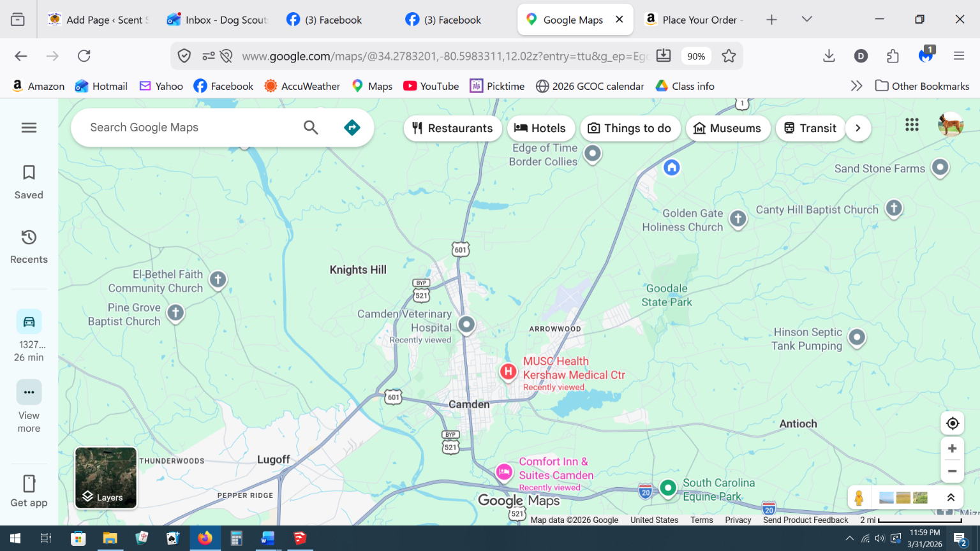
I-20

AKC Official Entry Form

Fetch Trial 1  Saturday May 2nd, 2026 | ◻Novice | ◻ Intermediate | ◻ Advanced | ◻ Retriever
Fetch Trial 2  Saturday May 2nd, 2026 | ◻Novice | ◻ Intermediate | ◻ Advanced | ◻ Retriever
CGC  CGCA  Tricks | o  o  oNovice | oIntermediate | oAdvanced | oPerformer  oElite
Entry fees: $20 per test (each check mark above)
Please bring cash for trial fees
# of tests entered: |  | X $20 | = $ _____________
# of tests entered: | ____________ | X $20 | = $ _____________
 |  | X $20 | Total due

 |  | AKC Registered Name |  |  |  |  |  |  | Registration Number
 |  |  |  |  |  |  |  |  | ◻ AKC/PAL/ILP/CP  ◻ Foreign
 |  | Call name | Date of birth |  |  |  | Sex
 |  | Breed
 |  | Owner
 |  | Owner’s Address
 |  | City |  |  | State |  |  |  |  |  |  | Zip
 |  | Telephone | Email
 |  | Handler name (if different from owner): |  |  |  | Junior Handler # (if applicable):

Fields marked in blue are REQUIRED.

Fields marked in gray must be completed if the information is known.

***Be sure to read the Agreement and sign on the reverse. No form will be processed without your signature!
Guidelines are available on the American Kennel Club Web site at:

www.akc.org/fetch

AGREEMENT

I certify that I am the actual owner of the dog, or that I am the duly authorized agent of the actual owner whose name I have entered. In consideration of the acceptance of this entry, I (we) agree to abide by the rules and regulations of The American Kennel Club in effect at the time of this event, and any additional rules and regulations appearing in the premium list of this event and entry form and any decision made in accord with them. I (we) agree that the club holding this event has the right to refuse this entry for cause which the club shall deem sufficient. I (we) certify and represent that the dog entered is not a hazard to persons or other dogs. In consideration of the acceptance of this entry and of the holding of this event and of the opportunity to have the dog judged and to win prizes, ribbons, or trophies, I (we) agree to hold the AKC, the event-giving club, their members, directors, governors, officers, agents, superintendents or event secretary and the owner and/or lessor of the premises and any provider of services that are necessary to hold this event and any employees or volunteers of the aforementioned parties, and any AKC approved judge, judging at this event, harmless from any claim for loss or injury which may be alleged to have been caused directly or indirectly to any person or thing by the act of this dog while in or about the event premises or grounds or near any entrance thereto, and I (we) personally assume all responsibility and liability for any such claim; and I (we) further agree to hold the aforementioned parties harmless from any claim of loss, injury or damage to this dog.

Additionally, I (we) hereby assume the sole responsibility for and agree to indemnify, defend and save the aforementioned parties harmless from any and all loss and expense (including legal fees) by reason of the liability imposed by law upon any of the aforementioned parties for damage because of bodily injuries, including death at any time resulting therefrom, sustained by any person or persons, including myself (ourselves), or on account of damage to property, arising out of or in consequence of my (our) participation in this event, however such, injuries death or property damage may be caused, and whether or not the same may have been caused or may be alleged to have been caused by the negligence of the aforementioned parties or any of their employees, agents, or any other person. I (we) agree that the determination of whether the injury is serious shall be made by the event veterinarian and is binding on me (us). I (WE) AGREE THAT ANY CAUSE OF ACTION, CONTROVERSY OR CLAIM ARISING OUT OF OR RELATED TO THE ENTRY, EXHIBITION OR ATTENDANCE AT THE EVENT BETWEEN THE AKC AND THE EVENT-GIVING CLUB (UNLESS OTHERWISE STATED IN THIS PREMIUM LIST) AND MYSELF (OURSELVES) OR AS TO THE CONSTRUCTION, INTERPRETATION AND EFFECT OF THIS AGREEMENT SHALL BE SETTLED BY ARBITRATION PURSUANT TO THE APPLICABLE RULES OF THE AMERICAN ARBITRATION ASSOCIATION. HOWEVER, PRIOR TO ARBITRATION ALL APPLICABLE AKC BYLAWS, RULES, REGULATIONS, AND PROCEDURES MUST FIRST BE FOLLOWED AS SET FORTH IN THE AKC CHARTER AND BYLAWS, RULES, REGULATIONS, PUBLISHED POLICIES AND GUIDELINES.

SIGNATURE of owner or his agent duly authorized to make this entry.

SIGN HERE

X:__________________________________________________________________________

Phone #: ___________________________________________________________________

Email: ______________________________________________________________________

In case of Emergency – Name: __________________________________ Phone #: ________________

